# **Project Documentation: StudyPalz AI Learning Platform**

|  |  |
| --- | --- |
| **Document Version:** | 1.0 |
| **Last Updated:** | August 1, 2025 |
| **Status:** | Final |

## **Table of Contents**

* [1. Introduction](https://www.google.com/search?q=%231-introduction)
  + [1.1. The Problem: The Inefficiency of "One-Size-Fits-All" Education](https://www.google.com/search?q=%2311-the-problem-the-inefficiency-of-one-size-fits-all-education)
  + [1.2. The Solution: A Hyper-Personalized Learning Ecosystem](https://www.google.com/search?q=%2312-the-solution-a-hyper-personalized-learning-ecosystem)
* [2. Capabilities Overview: What StudyPalz Can Do](https://www.google.com/search?q=%232-capabilities-overview-what-studypalz-can-do)
* [3. Core Features in Detail](https://www.google.com/search?q=%233-core-features-in-detail)
  + [3.1. AI-Powered Curriculum Generation](https://www.google.com/search?q=%2331-ai-powered-curriculum-generation)
  + [3.2. Dynamic & Multi-Faceted Content Delivery](https://www.google.com/search?q=%2332-dynamic--multi-faceted-content-delivery)
  + [3.3. Adaptive Assessment & Intelligent Quizzing](https://www.google.com/search?q=%2333-adaptive-assessment--intelligent-quizzing)
  + [3.4. Intelligent Progress Tracking & Mastery Modeling](https://www.google.com/search?q=%2334-intelligent-progress-tracking--mastery-modeling)
  + [3.5. Proactive Spaced Repetition System (SRS)](https://www.google.com/search?q=%2335-proactive-spaced-repetition-system-srs)
  + [3.6. Automated & Dynamic Scheduling](https://www.google.com/search?q=%2336-automated--dynamic-scheduling)
  + [3.7. Pre-Exam Power Pack Generation](https://www.google.com/search?q=%2337-pre-exam-power-pack-generation)
* [4. The StudyPalz Methodology: The Science Behind the System](https://www.google.com/search?q=%234-the-studypalz-methodology-the-science-behind-the-system)
  + [4.1. Pillar 1: Generative AI for Dynamic Curriculum & Content](https://www.google.com/search?q=%2341-pillar-1-generative-ai-for-dynamic-curriculum--content)
  + [4.2. Pillar 2: The Adaptive Mastery and Forgetting Curve Model](https://www.google.com/search?q=%2342-pillar-2-the-adaptive-mastery-and-forgetting-curve-model)
  + [4.3. Pillar 3: The Persona-Based Personalization Engine](https://www.google.com/search?q=%2343-pillar-3-the-persona-based-personalization-engine)
  + [4.4. Pillar 4: The Proactive Intervention Engine](https://www.google.com/search?q=%2344-pillar-4-the-proactive-intervention-engine)
* [5. Technical Architecture](https://www.google.com/search?q=%235-technical-architecture)
  + [5.1. System Overview](https://www.google.com/search?q=%2351-system-overview)
  + [5.2. Database Schema (models.py)](https://www.google.com/search?q=%2352-database-schema-modelspy)
  + [5.3. Code Structure & Core Components](https://www.google.com/search?q=%2353-code-structure--core-components)
* [6. Conclusion & Unique Advantages](https://www.google.com/search?q=%236-conclusion--unique-advantages)

## **1. Introduction**

### **1.1. The Problem: The Inefficiency of "One-Size-Fits-All" Education**

The modern educational landscape, particularly in the digital realm, is dominated by a "one-size-fits-all" approach. Traditional learning platforms present learners with static curricula and uniform content, failing to address the fundamental diversity in how individuals learn, what they want to learn, and the specific goals they wish to achieve.

This leads to several key challenges:

* **Static Curricula:** Learners are confined to predefined courses, making it impossible to create custom study plans for specialized professional exams, niche academic subjects, or personal interests.
* **Passive Learning:** Content is delivered in a singular format (e.g., text or video), ignoring the proven benefits of catering to diverse learning styles (visual, auditory, reading/writing, kinesthetic).
* **Inefficient Revision:** Students lack intelligent tools to guide their revision efforts. They are often left to guess which topics to focus on, leading to ineffective cramming or redundant studying of already-mastered concepts.
* **Lack of Personalization:** The learning experience fails to adapt to a user's evolving strengths, persistent weaknesses, or intrinsic learning preferences.
* **Generic Assessments:** Quizzes are typically static and repetitive, testing rote memorization rather than true understanding, and they do not adapt in difficulty based on user performance.

### **1.2. The Solution: A Hyper-Personalized Learning Ecosystem**

StudyPalz is architected from the ground up to solve these problems. It is an intelligent learning management system that creates a dynamic, responsive, and deeply personalized learning environment. By leveraging a powerful generative AI engine, StudyPalz transforms the learning process from a monologue into a dialogue, creating a bespoke educational journey for every user.

## **2. Capabilities Overview: What StudyPalz Can Do**

StudyPalz shifts the learning process from a static, passive experience to a dynamic, interactive partnership between the student and the AI. The platform empowers users with a suite of advanced capabilities:

* ✅ **Create and Personalize Any Course Imaginable:** Users are no longer limited by a predefined course catalog. By providing a syllabus from a university, a textbook's table of contents, or even just a simple list of topics, the AI can instantly structure a complete, modular study plan.
* ✅ **Master Concepts with Tailored Content:** For any lesson, the platform can instantly generate the type of content that best suits the user's learning style. Options include detailed **notes**, real-world **analogies**, practical **code examples**, or even **podcast scripts** for auditory learning.
* ✅ **Conquer the Forgetting Curve with Intelligent Guidance:** StudyPalz actively combats knowledge decay. The AI-powered **Mastery Model** tracks when a user is likely to forget a topic and automatically schedules a review at the optimal moment to reinforce and strengthen long-term memory.
* ✅ **Test Yourself with Adaptive, AI-Generated Quizzes:** Users can move beyond simple, repetitive questions. The system generates quizzes that adapt to the user's skill level, focus on specific weak points, and include complex **open-ended questions** which are graded by the AI, complete with nuanced scoring and constructive feedback.
* ✅ **Receive Proactive Guidance from an AI Learning Coach:** The platform functions as a personal academic coach. It performs a maintenance check on the user's schedule every night, automatically rescheduling missed tasks and adding targeted review sessions for topics the user is struggling with, providing helpful insights along the way.
* ✅ **Deeply Understand Your Own Learning Habits:** The "My Progress" dashboard offers a comprehensive analytics profile. Users can discover their unique **Learning Persona** (e.g., "The Visualizer" or "The Practitioner"), identify common mistake patterns, and view their progress over time with a holistic, AI-generated summary.
* ✅ **Generate a Final "Power Pack" for Exam Domination:** Before an exam, users can generate a definitive, personalized study guide. This "Power Pack" contains a universal cheat sheet for every topic, plus a special deep-dive section that provides in-depth tutorials on the user's weakest areas, with content style tailored to their personal learning persona.

## **3. Core Features in Detail**

Each capability is powered by a set of interconnected features built into the platform's Django backend and AI utility modules.

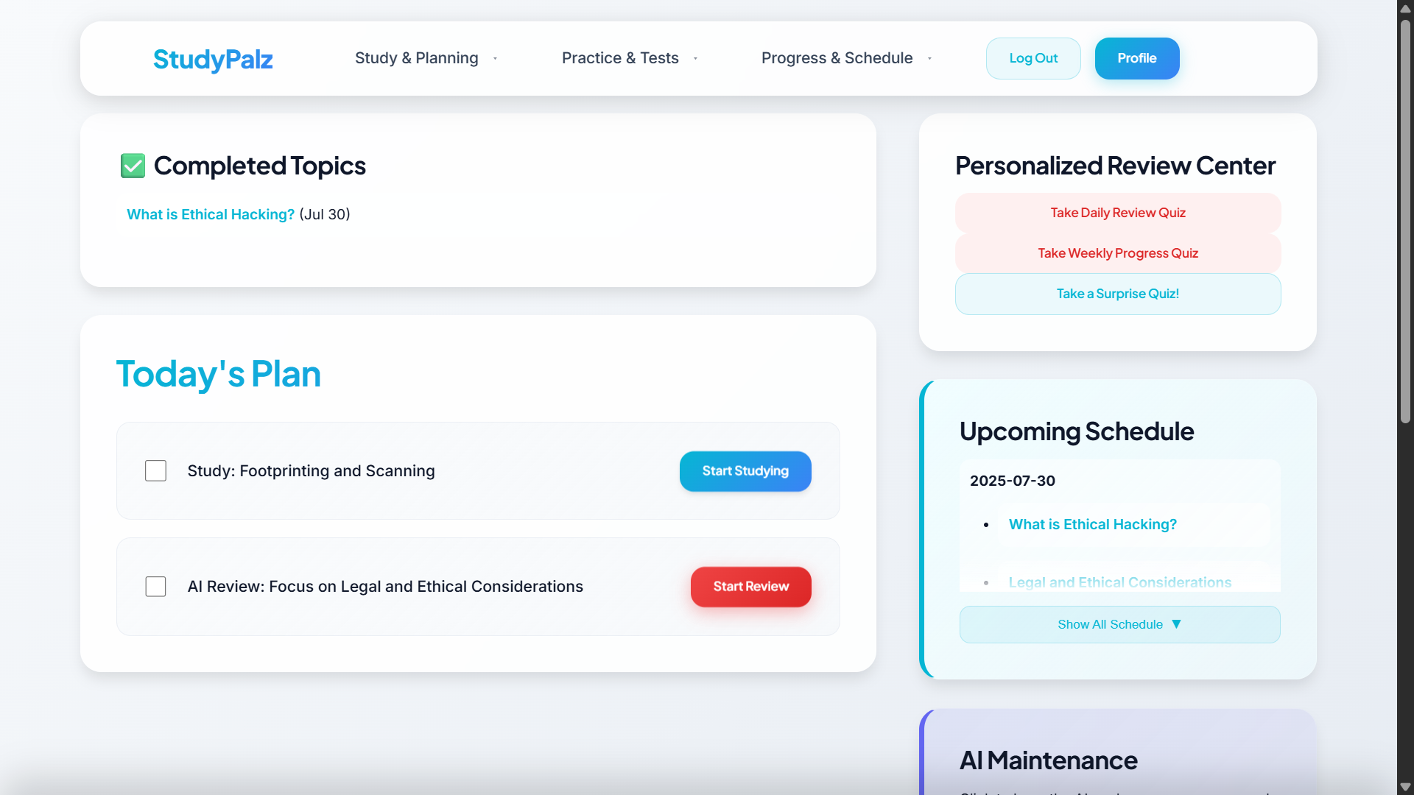

### **3.1. AI-Powered Curriculum Generation 📚**

* **Functionality:** Users input raw text (e.g., a syllabus). The generate_syllabus_structure function in ai_utils.py calls the Gemini API to parse this text and return a structured JSON object containing a subject, modules, and lessons.
* **Integration:** The generate_plan_view handles this interaction. Upon user confirmation in the save_plan_view, the system creates persistent StudyPlan, Module, and Lesson objects in the database.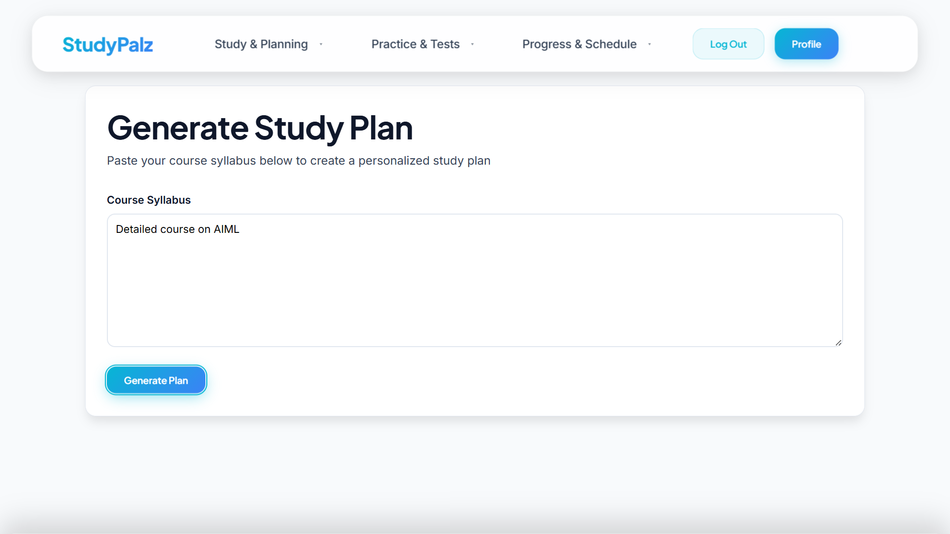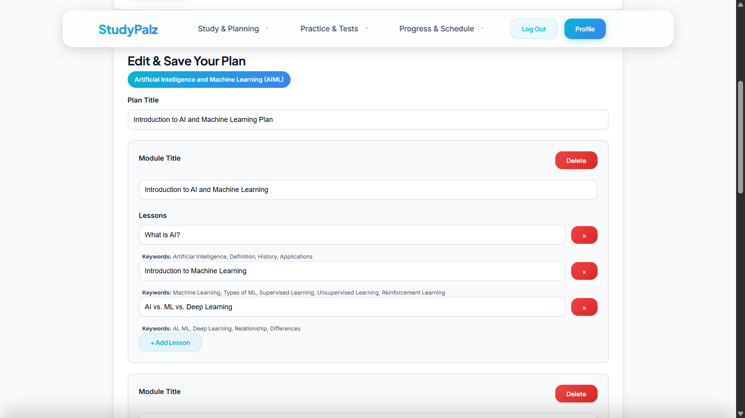

### **3.2. Dynamic & Multi-Faceted Content Delivery 🎧**

* **Functionality:** For any Lesson, the get_single_content_piece function can generate various content types (notes, analogy, example, podcast_script). The find_youtube_video function fetches a relevant video.
* **AI Tutor:** The ask_tutor_view allows users to submit a specific question. The get_tutor_response function uses the lesson's content as context to provide a direct, relevant answer, simulating a real-time tutor.

### **3.3. Adaptive Assessment & Intelligent Quizzing 📝**

* **Functionality:** The system features multiple quiz generation functions: generate_completion_quiz for individual lessons, generate_quiz_questions for custom practice sessions, and generate_adaptive_mock_exam for full-length, personalized exams. These functions construct detailed AI prompts that include the user's mastery level and historical weaknesses.
* **AI Grading:** The grade_open_ended_answer function is a key innovation. It sends the question, grading rubric, and user's answer to the AI, which returns a float score (e.g., 0.0−1.0) and constructive feedback.
* **Integration:** The submit_quiz_view orchestrates the entire process, routing answers to the correct grading logic (standard or AI) and triggering subsequent updates.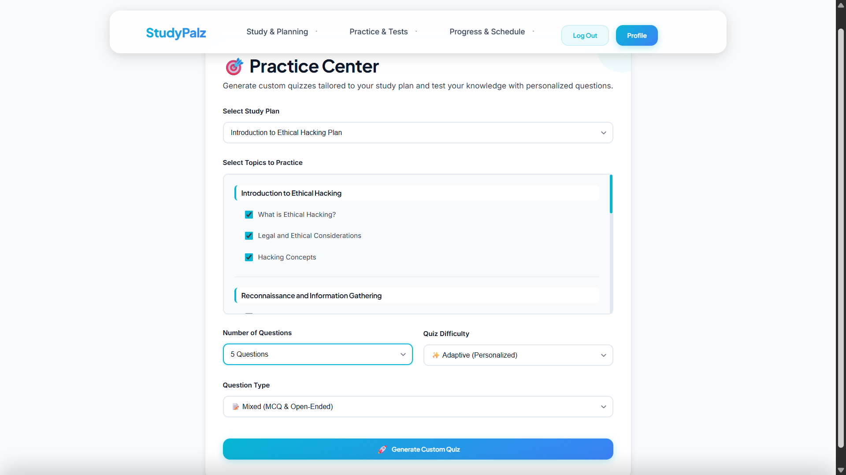
* 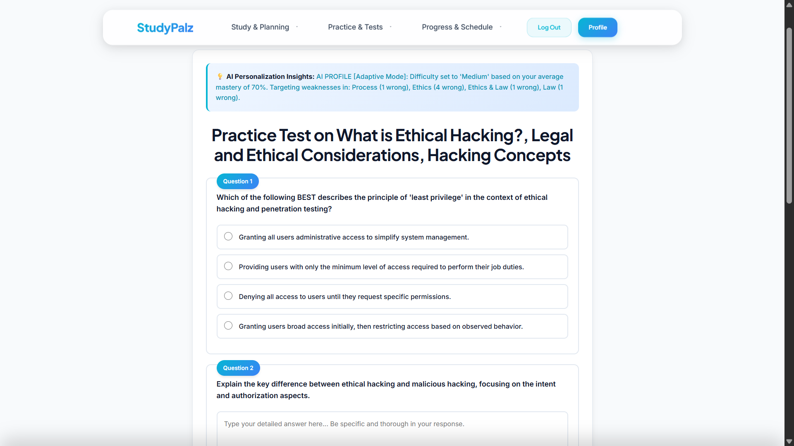
* 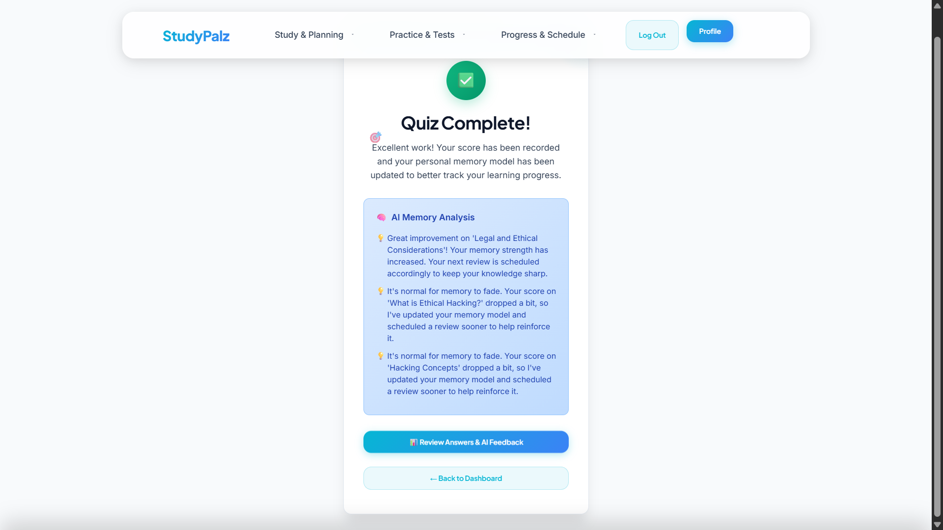
* 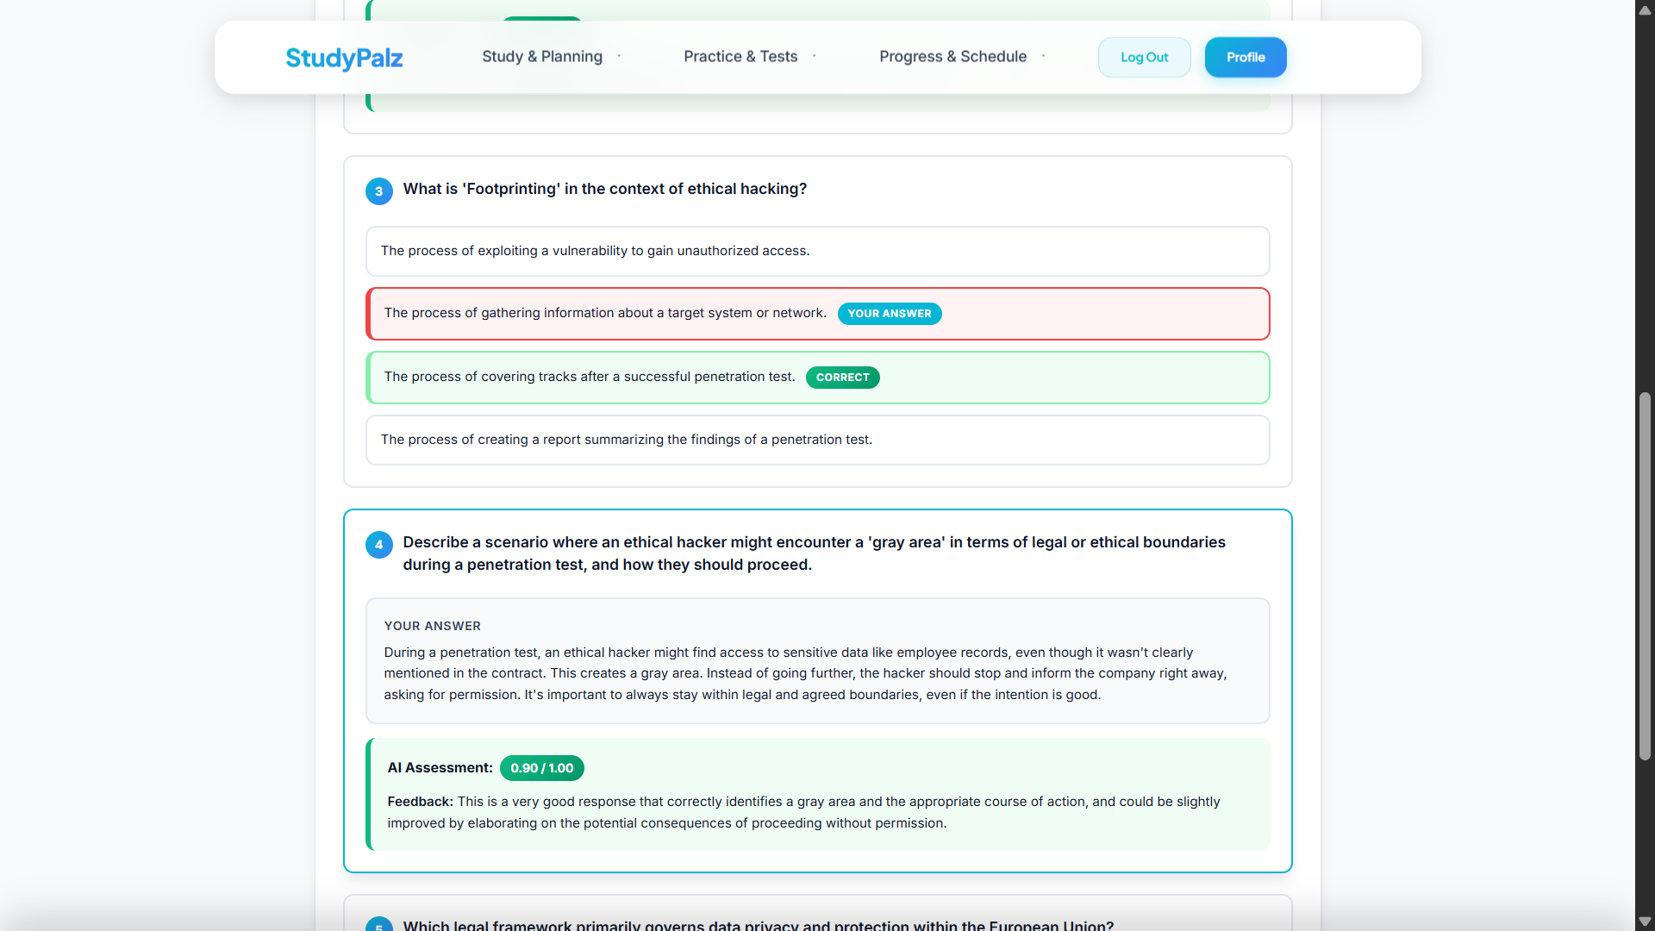

### **3.4. Intelligent Progress Tracking & Mastery Modeling 🧠**

* **Functionality:** The core of this system is the update_mastery_and_forgetting_curve function. After each quiz, it updates the user's Mastery score for the relevant lesson. It then calculates the user's **Memory Strength** and predicts the optimal **Next Review Date** based on a forgetting curve model.
* **Persona Detection:** The detect_learning_persona function analyzes a user's entire interaction history, with extra weight for positive feedback, to classify their learning style. This persona is then used to personalize future content.
* 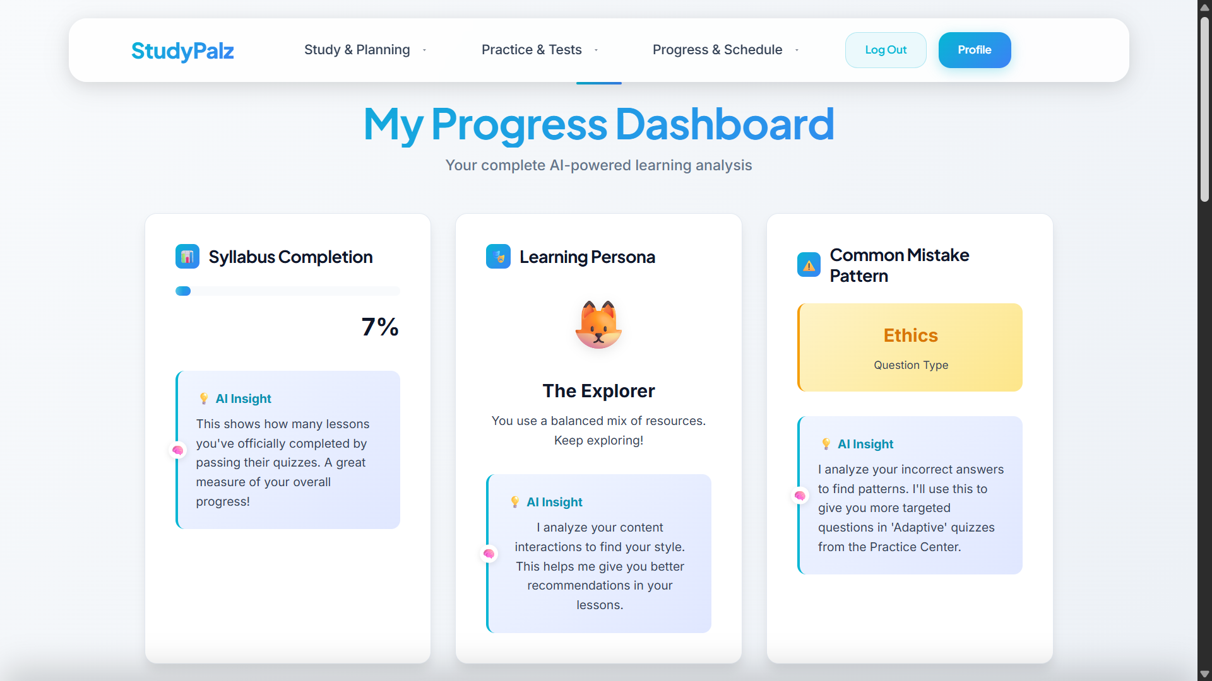

### **3.5. Proactive Spaced Repetition System (SRS) 🔄**

* **Revision Cards:** The generate_revision_card_content function creates a concise "cheat sheet" for a lesson. These RevisionCard objects are managed by an SRS algorithm in the process_revision_card_feedback_view, which adjusts the next_review_date based on user recall.
* **Targeted Flashcards:** The generate_targeted_flashcards_for_review function is triggered when the system identifies a particularly weak topic. It generates a new set of Q&A Flashcard objects to help the user drill down on specific problem areas.
* 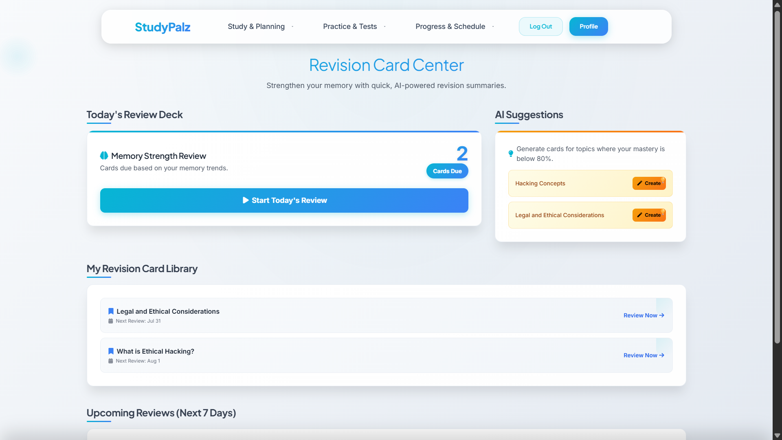
* 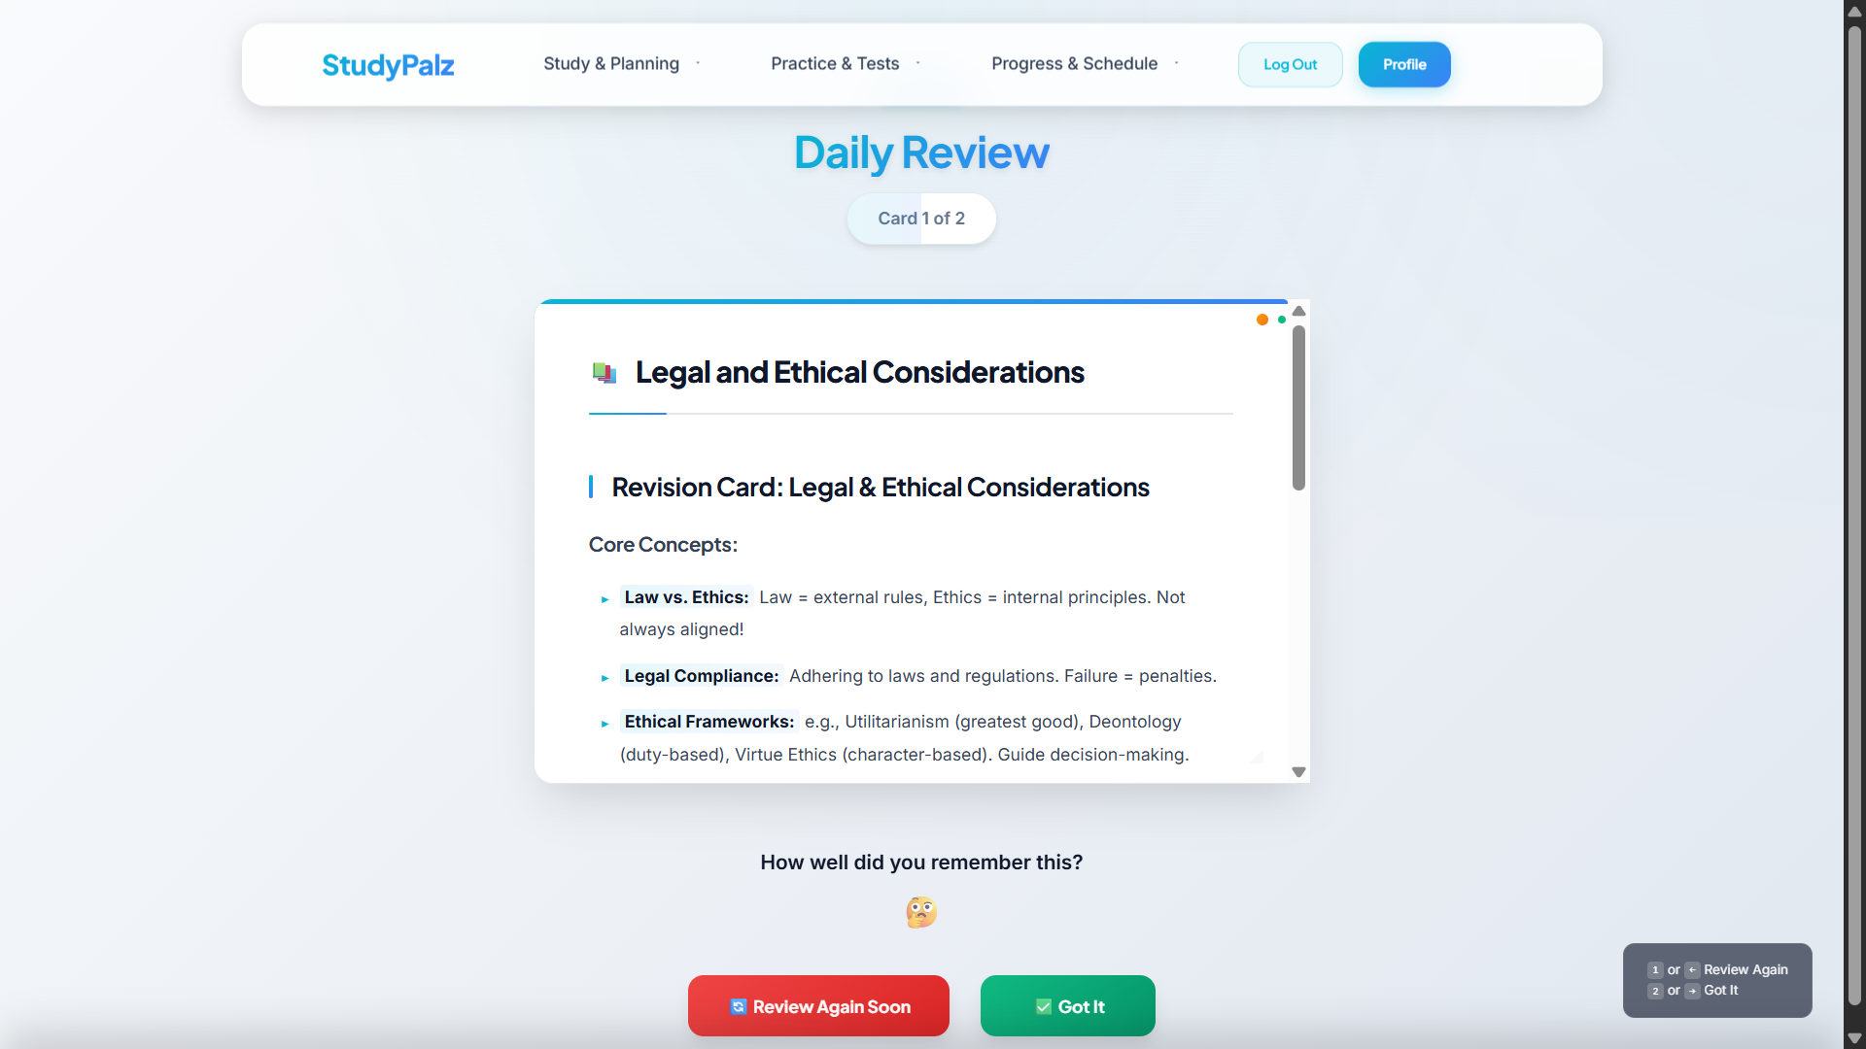

### **3.6. Automated & Dynamic Scheduling 📅**

* **Initial Setup:** create_advanced_schedule generates a balanced study calendar based on user inputs.
* **AI Maintenance:** The perform_daily_schedule_maintenance function runs as an automated nightly process. It finds weak topics, proactively schedules review tasks, generates new flashcards for those topics, and reschedules any tasks the user missed on the previous day. The analyze_quiz_and_reschedule function does this immediately after a quiz, scheduling reviews for incorrectly answered topics.
* 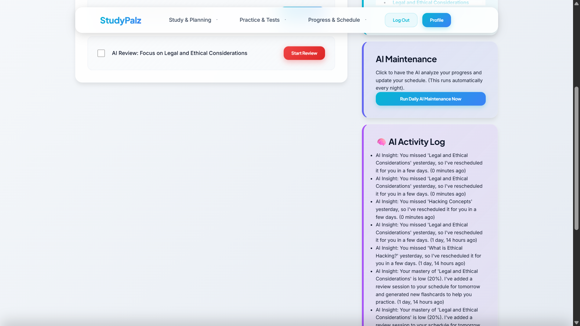

### **3.7. Pre-Exam Power Pack Generation ⚡**

* **Functionality:** The generate_pre_exam_power_pack function is a capstone feature. It compiles a comprehensive Markdown document that includes a cheat-sheet for all topics and a personalized "deep-dive" section that explains the user's weakest topics in a style that matches their learning persona. This is saved as a PowerPack object.
* 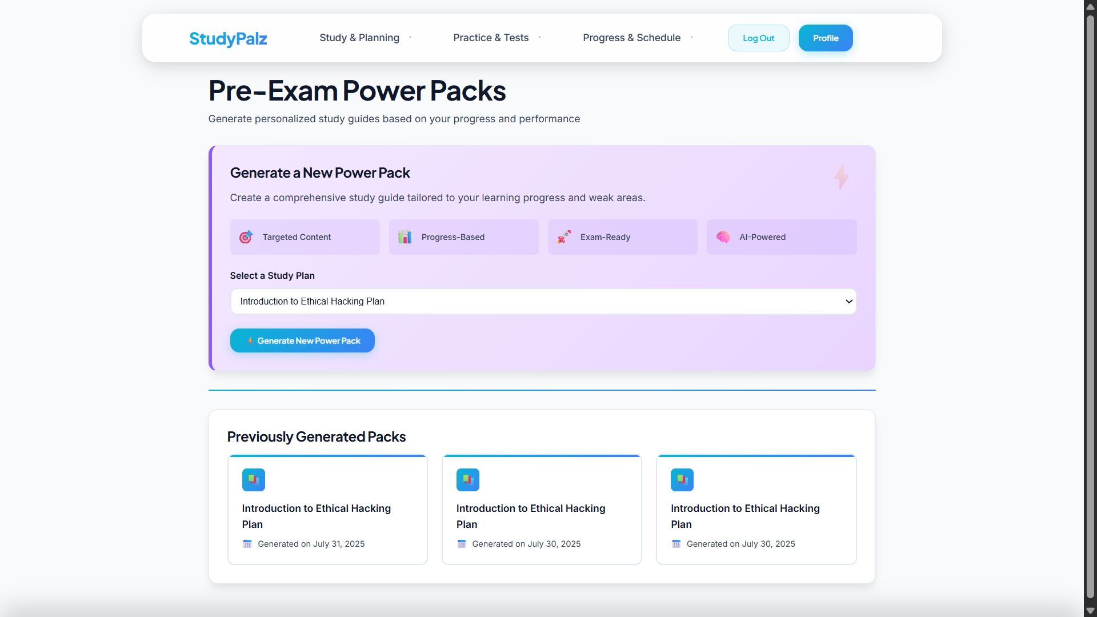
* 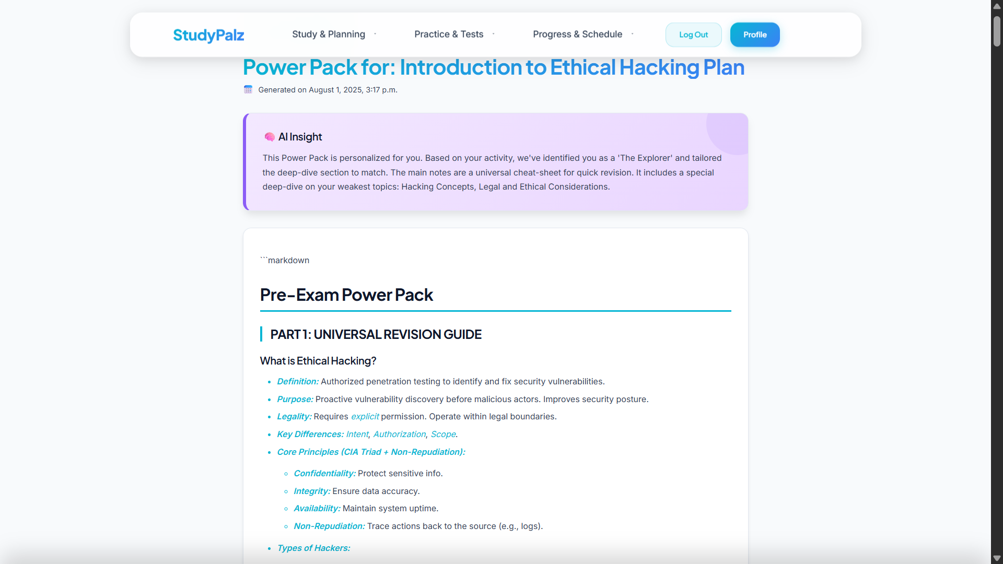
* 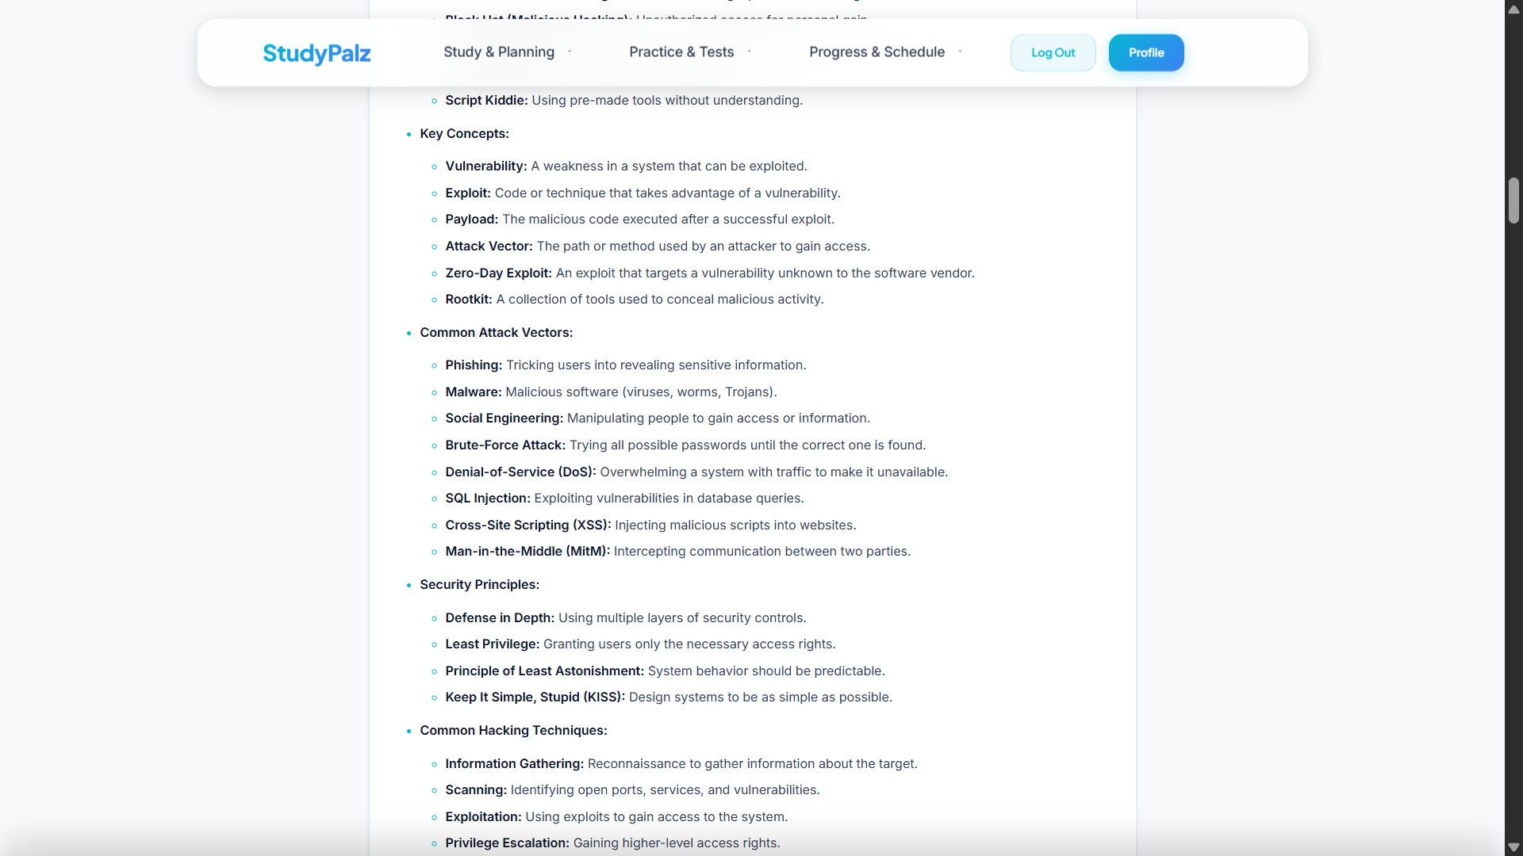
* 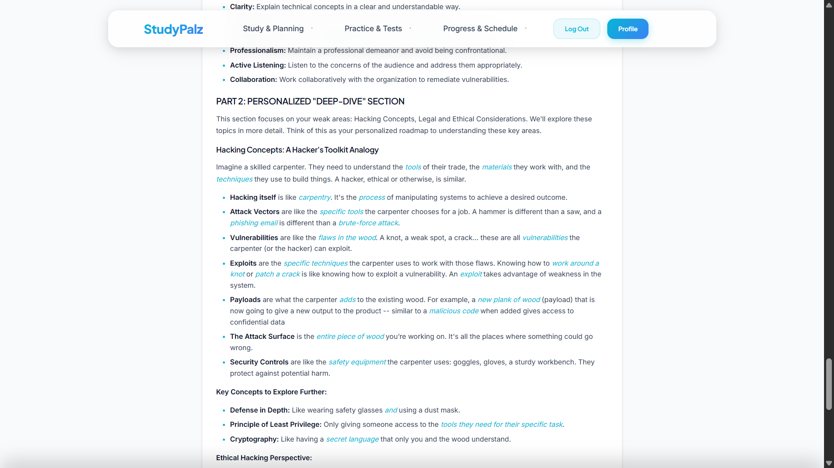

## **4. The StudyPalz Methodology: The Science Behind the System**

The platform's intelligence is an ecosystem built on four core methodological pillars, combining cognitive science principles with the power of modern Large Language Models (LLMs).

### **4.1. Pillar 1: Generative AI for Dynamic Curriculum & Content**

The foundation of StudyPalz is the use of a generative AI (Google Gemini) to break free from the constraints of static, pre-authored content.

* **Instruction-Driven Architecture:** Instead of storing fixed content, the system stores *instructions* (prompts) for generating that content. Through sophisticated prompt engineering, we guide the AI to produce high-quality, structured output on demand, such as converting unstructured text into valid JSON for a syllabus or creating complex assessments based on a user profile.
* **Content Pluralism:** This generative approach allows us to offer multiple "views" of the same core concept. A single lesson topic can be manifested as notes, an analogy, a code example, or a podcast script. This caters to diverse learning styles without requiring the manual creation of each content type, making the platform scalable to any subject matter.

### **4.2. Pillar 2: The Adaptive Mastery and Forgetting Curve Model**

This is the scientific heart of the platform's personalization engine, turning the abstract theory of memory into a practical, computational model. It is inspired by the **Ebbinghaus Forgetting Curve**, which posits that memory decays exponentially over time if not reinforced. Our model tracks two key metrics for each user and each lesson:

* **Mastery Score (**M**):** A value from 0.0 to 1.0 that reflects a user's performance on their most recent quiz for a given topic. This metric represents **immediate knowledge** and is a direct indicator of current performance. It is reactive and can change significantly after a single assessment.
* **Memory Strength (**S**):** A more durable, long-term metric representing the "stickiness" or resilience of a memory. It is influenced by repeated, successful recalls over time.
  + When a topic is first learned, S is initialized based on the initial quiz score.
  + With each subsequent review, the change in strength is calculated based on performance gain and the natural decay that has occurred since the last test. The conceptual formula is: DeltaS=textPerformanceGain−textDecayFactor.
  + A high Memory Strength indicates that a concept has been successfully recalled multiple times over spaced intervals and is likely stored in long-term memory. A high score on a single quiz yields a high M but only a modest initial S.
* **The Scheduling Algorithm:** The core of our Spaced Repetition System (SRS) lies in how Memory Strength dictates the future. The time interval until the next optimal review is a direct function of the Memory Strength: NextReviewInterval=f(S). A low S results in a short interval (e.g., 1-2 days), while a high S results in a much longer interval (e.g., weeks or months). This ensures that the student's revision time is always focused on the material they are most at risk of forgetting.

### **4.3. Pillar 3: The Persona-Based Personalization Engine**

StudyPalz learns not just *what* a student knows, but *how* they prefer to learn. This is achieved through a continuous feedback loop.

* **Implicit & Explicit Data Collection:** The system logs all user interactions (UserInteraction model), including implicit data (e.g., viewing a video) and explicit data (e.g., clicking "Helpful" 👍).
* **Weighted Analysis:** The detect_learning_persona function analyzes this corpus of interaction data. Crucially, it applies a higher weight to explicit positive feedback. A single "Helpful" click on an analogy is more influential in shaping the user's persona than multiple passive views of notes.
* **Persona as an AI Parameter:** The output is a "Learning Persona" (e.g., The Scholar, The Visualizer). This persona becomes a critical input parameter in subsequent prompts to the AI. When generating a PowerPack or recommending content, the AI is explicitly instructed to tailor its response to the user's identified learning style.

### **4.4. Pillar 4: The Proactive Intervention Engine**

A key differentiator for StudyPalz is its proactive, rather than reactive, nature. The system is designed to anticipate and mitigate learning challenges.

* **Automated Diagnostics:** The perform_daily_schedule_maintenance function acts as an automated diagnostic tool that runs for each user. It does not wait for the user to report a problem.
* **Trigger-Based Intervention:** The engine uses specific triggers—such as a Mastery Score dropping below a certain threshold or a scheduled task being missed—to initiate an intervention.
* **Intelligent Intervention:** The intervention is multi-faceted. The system actively reschedules the task, generates new, targeted practice materials (like flashcards), and sends an encouraging, AI-written notification explaining what it did and why. This transforms the platform from a passive tool into an active learning partner.

## **5. Technical Architecture**

### **5.1. System Overview**

StudyPalz is a monolithic web application built on the **Django** framework using Python. The AI capabilities are powered by external API calls to **Google's Gemini Pro** model. The frontend is rendered using standard Django templates with HTML, CSS, and JavaScript for dynamic interactions (e.g., fetching content via AJAX, handling quiz submissions).

### **5.2. Database Schema (models.py)**

The PostgreSQL database schema is designed to be relational and robust, capturing all facets of the user's learning journey.

* **Curriculum Structure:** User -> StudyPlan -> Module -> Lesson. This forms the hierarchical basis of a user's course.
* **Assessment Structure:** A Quiz (with a quiz_type field like 'lesson' or 'mock_exam') contains multiple Questions. A QuizAttempt by a User logs their UserAnswers. Open-ended answers are stored with their ai_score and ai_feedback.
* **User Analytics Data:**
  + Mastery: The central model for personalization. Links a User and a Lesson to store the mastery_score, memory_strength, and next_review_date.
  + UserInteraction: Logs every click and feedback action, providing the raw data for persona detection.
* **Scheduling:** ScheduledDay links to a StudyPlan and a date. Each day can have multiple ScheduledTasks, which can be of type 'STUDY', 'REVIEW', etc.
* **Content Abstractions:** Flashcard, RevisionCard, and PowerPack models store AI-generated content for review and study purposes.

### **5.3. Code Structure & Core Components**

The application logic is well-encapsulated into distinct components.

* **models.py:** Defines the entire database structure, relationships, and data constraints. It is the single source of truth for the application's data architecture.
* **ai_utils.py:** The brain of the application. This module contains **all AI-related logic** and communication with the Gemini API. It is deliberately decoupled from Django's request-response cycle. Functions in this file accept standard Python data types and return processed data or JSON strings.
* **views.py:** The controller layer. These functions handle HTTP requests, authenticate users, retrieve data from the database via the models, call the necessary processing functions from ai_utils.py, and render the final HTML templates with the appropriate context.

## **6. Conclusion & Unique Advantages**

StudyPalz represents a significant step beyond traditional e-learning platforms. By integrating a powerful generative AI at its core, it offers a suite of unique advantages:

* **Truly Dynamic Curriculum:** Empowers users to become curriculum designers for their own learning journey.
* **Proactive Revision:** The system acts as a personal academic coach, actively identifying weaknesses and automatically scheduling targeted review sessions.
* **Deep Personalization:** The platform adapts not just the *path* of learning but the *style* of the content itself through persona detection.
* **Advanced Assessment:** Moves beyond multiple-choice by using AI to grade open-ended questions, assessing a deeper level of understanding.
* **Actionable Insights:** The analytics dashboard doesn't just display data; it uses AI to interpret that data, providing users with clear, holistic summaries and concrete advice for improvement.

**By addressing the core inefficiencies of static, one-size-fits-all education, StudyPalz provides a more effective, engaging, and ultimately more human-centric approach to digital learning.**